| 🏁 🔐 🏁 **FRONT MATTER** 🏁 🔐 🏁  **About this doc:** This is a summary of the research the Studio team has been doing since April 2022, outlining what we’ve done thus far, our preliminary conclusions, and potential next steps.  **Intended audience:** Right now, this is intended for the purposes of onboarding new team members to the Benefits Studio, as well as informing other teams within TTS. We plan to repackage a version of these findings for public consumption at a later date.  **How to interact with this doc:**  Please don’t hesitate to add comments, questions, or additional context you may have—think of this as a living document! |
| --- |

TTS Public Benefits Studio research snapshot as of July '22

# In short…

Since late April 2022, Amy Ashida and Alex Pandel from the Studio team have been **pursuing two simultaneous threads of research and outreach** to identify the Studio’s initial area(s) of focus and nurture relationships with other gov and non-gov organizations working to improve public benefits delivery. These included:

1. **Exploring notifications as a potential “first bet”**, in collaboration with the 10x Government Notifications Service (GNS) team, who have already forked [UK Notify.](https://www.notifications.service.gov.uk/)
2. **Collecting feedback on other potential focus areas** and opportunities to collaborate with others in the space.

### Our research thus far has **led us to the following preliminary conclusions:**

* Of [the opportunity areas](https://docs.google.com/document/d/14zSvFhpvSkU22XcnPjwsKy0Pl5OpSWMGwUjqdZcBsuU/edit) we were considering, **improving notifications appears to be the right place for the Studio to invest** first.
* Most of our remaining questions about the viability of offering a central notifications service (around ease of use, appetite for adoption, etc) will be **best answered by getting a working prototype into the hands of agency users.**
  + Other than **the known bottleneck of achieving ATO**, testing a prototype with users should be relatively straightforward given **the existence of well-supported, open source codebases to start from**, andsince we heard repeatedly that **there’s value in an exceedingly simple solution**.
* As we explore the notifications space (and beyond), **it’s worthwhile to consider *both*:**
  + **Centralized approaches** (like building shared products/services), AND
  + **Decentralized approaches** (like promoting standards and best practices, debunking incorrectly assumed policy limitations, and offering implementation support).
    - **There may be “quick win” opportunities in:**
      * **aggregating and promoting the numerous existing toolkits/best practice guides** related to improving notifications.
      * **partnering with agencies looking to create model content for mail-based notices** to add SMS/email versions.
      * **Publishing our own market research** for agencies considering starting to use SMS.
* As we pursue shared tools and resources that span across programs and levels of government, we’ll need to be mindful of **benefits agencies having extremely limited bandwidth to take on new things** right now, especially with Public Health Emergency unwinding and staff turnover, as well as the **lack of established precedent for robust cross-program collaboration.**

### Given those conclusions, **a few next steps we plan to pursue include:**

**Co-design with benefits agencies and other collaborators to create repeatable notifications plays:**

* Bringing together current knowledge into a playbook for standing up a new SMS or email practice. Rather than conducting a series of 1:1 discussions with different actors in the benefits space, we see a number of advantages to convening these groups to have these discussions *together,* via [a series of topic-based “Summits.](https://docs.google.com/document/d/1T-VbuM1vqTmO2cCa7GT8yXDugu3xZ_vG9_z0h4clf2w/edit#)”
* Developing model content for [common use cases](https://github.com/department-of-veterans-affairs/va.gov-team/blob/master/products/va-notify/notification-guide.md#key-notification-types) across programs. This would allow us to start testing effective message content and support existing plain language efforts across multiple programs. This could also include content for languages other than English.

*AND*

**Prototyping & piloting a notifications-related offering:** We see a few options here:

* *Current plan:* Continuing to collaborate with the 10x GNS team to build and ATO a simple notification service to test with agency users. This would allow us to test if a shared service hosted by TTS would be appealing to agencies, and how feasible it would be for us to manage & operate that service.
* *Backup plan:* If pursuing the GNS ATO is not the best path for the Studio, we could utilize existing SMS tools that are already GSA approved (ex. Hubspot, Amazon SNS) to help agencies pilot more effective multi-channel communications across programs (e.g. clarifying if/when agencies *can* or *should* use SMS/email; identifying effective triggers to send messages and who should send/receive them.

**Answering remaining open questions:**

* How do we acknowledge and work within the reality moving forward that benefits agencies (especially at the state & local levels) are already operating at close to max capacity?
* How do we get folks across multiple levels of program orgs engaged in the discussion/pilots (so we can address the *whole* problem, from higher-level policy to on-the-ground implementation)?

# In more depth…

## Exploring notifications

### 

**Why notifications:**

* It’s well established at this point that improving the quality and successful delivery of notifications to program participants [greatly reduces the incidence of churn](https://bdtrust.org/SNAP-Churn_Final.pdf) (people being unenrolled and then re-enrolling to programs within a few months), and [can help increase cross program eligibility awareness and enrollment.](https://bdtrust.org/cbpp-bdt-wic-texting-guide.pdf) It’s also well established that offering SMS & email options greatly increases the [likelihood of successful delivery and follow through](https://uplandsoftware.com/adestra/resources/blog/sms-vs-dm-vs-email-gives-best-roi-fight/) (as opposed to relying on mail notices only). SMS programs have also demonstrated [improved population and program outcomes](https://community-nutrition-education.extension.org/texting-programs-in-snap-ed/).
* Despite this, not all states are currently offering email & SMS notifications to participants, and even among those that are, there’s inconsistency in the clarity and quality of the messages.
* Improving the quality and accessibility of government communications with the public also directly supports the current administration’s commitment to improving the customer experience of government (as outlined in [the President’s Management Agenda](https://www.performance.gov/pma/vision/#section-8) and [Customer Experience Executive Order](https://www.whitehouse.gov/briefing-room/presidential-actions/2021/12/13/executive-order-on-transforming-federal-customer-experience-and-service-delivery-to-rebuild-trust-in-government/)).

**Our goals/hypotheses:**

* We believe there’s an opportunity for TTS to help resolve some of these outstanding issues, given TTS’s mandate to serve *all* of government (not just a single program), and our willingness to own & operate shared services.
* We are exploring how the Studio can best support in this space: would it be more valuable to provide a TTS-operated shared service? Aggregating & sharing model content, implementation guidance, and other best practices? Both?
* Anti-goal: We’re *not* trying to move agencies who are already using SMS/email away from their current provider; we're focusing on reaching agencies who are not currently offering those modes of notifications *at all*, with the goal of raising the “floor” of the public experience across the board.

**Our approach:**

* We gathered insights from [a variety of existing sources](https://docs.google.com/spreadsheets/d/1KxRYbLZMRF-KuJTgvDdznjkS58aXwasCtEeHeXVILKQ/edit#gid=0) related to government notifications (reports from past research and pilots; existing best practice guides & implementation toolkits), and conducted 1:1 conversations with a number of organizations who’ve run SMS/email notification pilots in different government contexts.

**What’s still outstanding:**

* We haven’t conducted especially thorough market research around how many state agencies *are* already offering SMS and/or email notifications vs. aren’t, and of those that are, which tools are most commonly being used.
* We have not yet fully integrated some of the more technical research conducted by the 10x GNS team, or some of their [competitor capabilities research](https://docs.google.com/spreadsheets/d/1gSFwPjWQ73WSxP1lnIqCLsfbFpXxTqf-5DJDs0vzG-k/edit#gid=1534149995), which may be useful.
* [We’ve identified](https://app.mural.co/t/gsa6/m/gsa6/1653331712180/ad7c5a42536c6375869c08da02dac11ebdaa1a0b?wid=0-1654280938650) a number of existing best practice/implementation guides, but have not yet crosswalked the recommendations to see how much overlap exists. If we decide that offering toolkits/best practices is worthwhile, that will likely be a valuable next step.
* We haven’t thoroughly tested our current hypotheses around [why more states are not utilizing SMS and how our next steps will address those challenges.](https://docs.google.com/document/d/14-EoF-4Z_Gl2EJEZJekAMtDNDtoBjPYGfLLvUjMsqPE/edit)

## Exploring other focus areas

**Our goals/hypotheses:**

* Based on lessons learned over the last several years of work in the benefits space, we know that any efforts to improve the public’s experience of government benefits will require trusting relationships and collaboration across many different agencies and levels of government.
* And given that so much work is already happening in this space both inside and outside of government, it will be critically important for our team to be aware of and connected to other work happening in the space.

**Our approach:**

* Because of this, we’re investing early in nurturing relationships with existing organizations working in this space, both inside and outside of government.
* So far we’ve been doing this both [via 1:1 conversations](https://docs.google.com/spreadsheets/d/19Paw-ItuW1VACUT1DxHq_Sk5_43_a97EZFIZTdPeASU/edit#gid=0) with individual organizations, and by plugging into existing cross-org collaboration work being led by OMB as part of the Life Experiences discovery sprints (particularly the sprint focusing on people “facing a financial shock”).
* As part of these conversations, [we’re exploring](https://docs.google.com/document/d/1vfc1lf9AJ5v5sV4E-OQE9XIoPYia4NdlrflssPVBs_4/edit#heading=h.zcrfwxfyjnba):
  + The priorities & pain points that are top of mind for them (and whether/how those line up with [our own potential focus areas](https://docs.google.com/document/d/14zSvFhpvSkU22XcnPjwsKy0Pl5OpSWMGwUjqdZcBsuU/edit#heading=h.a2saz2rvrhrn))
  + How we could support *them*, particularly given our positioning from a federal, cross-agency vantage point

**What’s still outstanding:**

* There are still a number of other orgs we haven’t had the chance to speak to, and we expect this kind of outreach to be an ongoing effort that is never really “done,” so continued relationship development & collaboration should be expected.
* Because reciprocity is important to us, we want to be sure to share back a summary of our research (particularly around notifications) for the benefit of the broader community, so working up that more public report/writeup/demo will be an important next step.

## 

## Who we’ve talked to so far

1. CMS
2. FNS
3. DOL
4. Code for America
5. USDR
6. States of WA, CO, MT
7. Financial Shock Life Experience OMB team
8. Canada Notify team
9. UK Notify team
10. Beeck Center
11. Center for Budget and Policy Priorities
12. Federal Interagency Council on Economic Mobility
13. Benefits Data Trust
14. Public Policy Lab

## 

## What we’ve learned

### Overall

Our research validated that of [our 3 potential focus areas](https://docs.google.com/document/d/14zSvFhpvSkU22XcnPjwsKy0Pl5OpSWMGwUjqdZcBsuU/edit#heading=h.a2saz2rvrhrn), **improving notifications appears to be the most promising to start with.**

* Notifications and document uploading were both deemed promising given that they can add value even without connecting to or needing to alter or replace any existing, legacy systems (which can be a major hurdle to adoption).
* Notifications had the added benefit of supporting a number of benefits agencies’ priorities around improving the customer experience (CMS, WIC, and DOL have SMS as part of their future ideal service journey).
* Improved data sharing was also deemed valuable, but also significantly higher effort.
* Rules as code emerged as least promising as a starting place, given that it was both quite high effort and harder to demonstrate the value to the public.

Another major theme that emerged was **the tension between pursuing a centralized delivery model, vs. intentionally supporting a more decentralized model.**

* Given the framing of our inquiry, we definitely heard support for and interest in seeing GSA offer central shared products/services such as a Notification Service.
* That said, several of the folks we spoke to thought our best value to the space given our positioning and the inherently decentralized structure of benefits programs was supporting a more decentralized approach, such as:
  + Helping set and implement standards and share best practices (to support agencies to raise the “floor” of the public experience)
  + Centralizing and sharing knowledge about existing work in the field (to help a diverse ecosystem of actors build upon one another’s progress and avoid duplicative effort)
  + Focusing on providing *implementation* support over *product development* support, such as:
    - “Myth-busting” policy explanations to grant permission for using more effective but less common practices (eg, defaulting to opt-out consent vs opt-in for SMS)
    - Offering research ops as a service (research participant recruitment/compensation, etc)
    - Deploying short bursts of delivery team support to help states implement particular proven best practices/services to improve benefits delivery

Many of the sources we consulted called out that even more than usual, **agencies (especially at the state/county level) currently have especially low capacity for new, experimental “pilots.”**

* Any new interventions will likely need to be deeply aligned with their current top priorities (unwinding from the Public Health Emergency [PHE] waivers being a dominant one), and will need to come with enough additional resources (funding, staff, realistic implementation timeline) for states to be able to take them on sustainably.

Despite the huge overlap in populations served, **there is not a deeply established precedent for close collaboration *across* benefits programs.**

* While several interagency councils/coalitions do exist, a lot of them are new, haven’t delivered specific things we could find yet, and are either composed primarily of senior leadership (and therefore are more risk averse/further from the on-the-ground needs), OR primarily of line-level staff (and therefore less able to make the policy change that’s often necessary to enable more effective delivery of benefits).
* There may be an opportunity for the Studio to support bridging the gap between those two levels in pursuit of experience improvements that address both the public’s interaction with these programs, *and* the policies that fundamentally shape those interactions.

### Related to notifications specifically

There’s already significant, documented evidence that **improving the clarity, timeliness, and successful delivery of notifications to program participants greatly reduces the incidence of churn and reduces burden** and confusion overall.

* There have been a number of successful pilots in various US states (and other countries) that show high impact, and we’re in the process of speaking with each of these teams to learn about challenges, best practices, and what they’d do differently.
* The need to improve notifications was also a prominent theme in the current research with members of the public as part of the OMB Facing Financial Shock life experience discovery sprint.

Since the value of improving notifications is not really in question at this point, **most of our remaining questions (around ease of use, appetite for adoption, etc) will be best answered by getting a working prototype into the hands of agency users** as quickly as possible.

Luckily, **there are well-supported, open source codebases that give us a robust starting point**, so getting a working prototype stood up is not particularly challenging technically.

* And given that our focus is on supporting agencies/programs who aren’t currently offering email/SMS notifications *at all* (vs. trying to entice agencies away from an existing email/SMS provider), **we heard repeatedly that there’s value in an exceedingly simple solution.**
  + For example, a central tool that allows agencies to upload a .csv of phone numbers and messages would likely meet the core need without requiring any transmission of identifiable PII or integration with existing systems.
* **Our primary challenge now will be speeding our path to ATO** to be able to begin testing a product with actual agency users as soon as possible.

In the meantime, there are a number of best practice guides/implementation toolkits for benefits-related notifications that already exist, and **there could be a “quick win” opportunity in the Studio helping centralize, lend authority, and promote these existing resources**.

### Relevant journey maps that informed our hypotheses

* From 2016 [USDS + 18F research into enrollment gaps](https://github.com/18F/public-benefits#hhscms-multi-program-enrollment-prototype)
  + The applicant journey from [the public report](https://usds.github.io/benefits-enrollment-prototype/assets/discovery-findings-mapping-enrollment-Nov2016.pdf):

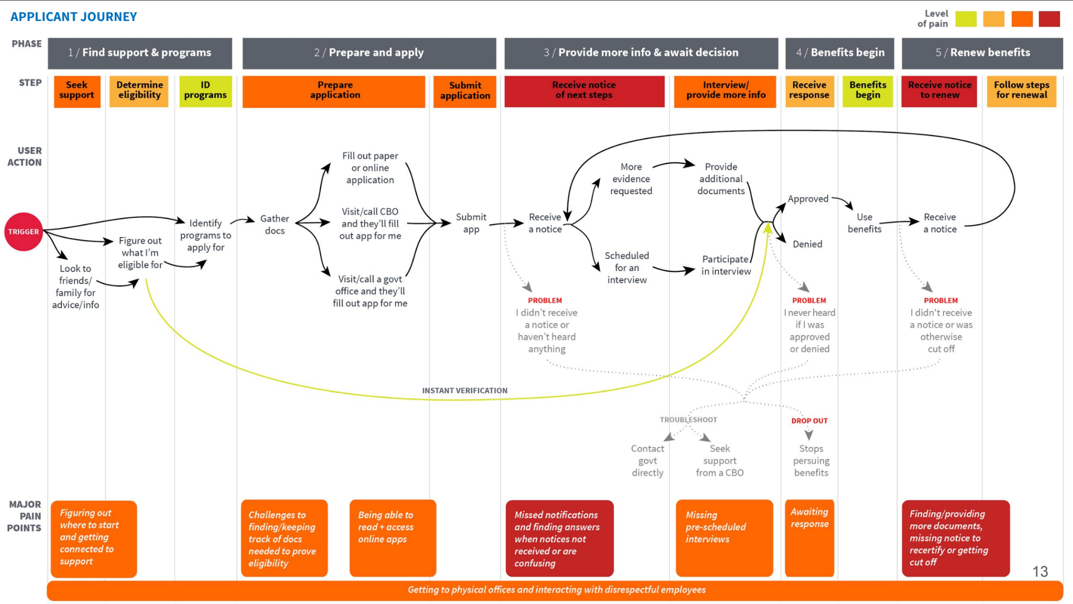

* + - the report also includes applicant stories starting on pg 23, and detailed quotes and paint points from each stage of the journey on pg 36
    - An earlier [mural version](https://app.mural.co/t/gsa6/m/gsa6/1458156242184/e366cbf8c0627efb192b87ccdf779f072362f838?invited=true&sender=amyashida5338) of the above, including quotes from interviews
  + A [service blueprint](https://app.mural.co/t/gsa6/m/gsa6/1460746209594/953e7721e4de94fba343bcc61fe9ed02b0f21b5e) of the state administrator’s process shows the “backstage” view of this journey
* From the [2022 USDS + WIC research + future service planning](https://www.figma.com/proto/hkqNI1hO6bbRlc60YzZ7M7/wic-future-state-service-blueprint?node-id=673%3A2022&scaling=min-zoom&page-id=652%3A360&starting-point-node-id=673%3A2022) 
  + 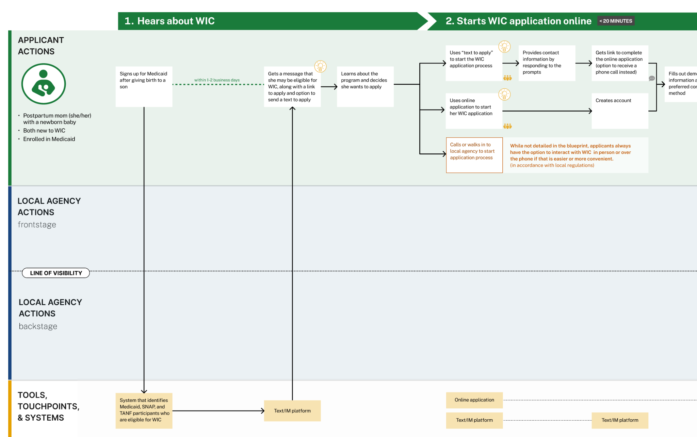
* From [2014 Kaiser Family Foundation work with the Michigan Primary Care Association](https://www.kff.org/wp-content/uploads/2013/05/8441-profiles-of-medicaid-outreach-and-enrollment-strategies1.pdf) 
  + *“Prior to implementation of this initiative, health centers in Michigan were finding it was increasingly common that the families they were assisting with Medicaid and CHIP enrollment were not new to the system, but had been previously been enrolled and lost coverage due to an incomplete renewal or missed deadline.”*
  + 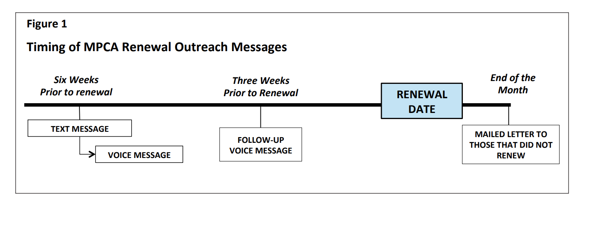
  + Over the first six months of the pilot, retention rates were, on average, 14% higher for children in participating health centers than other children
* From 2022 Facing Financial Shock Life Experience research:
  + 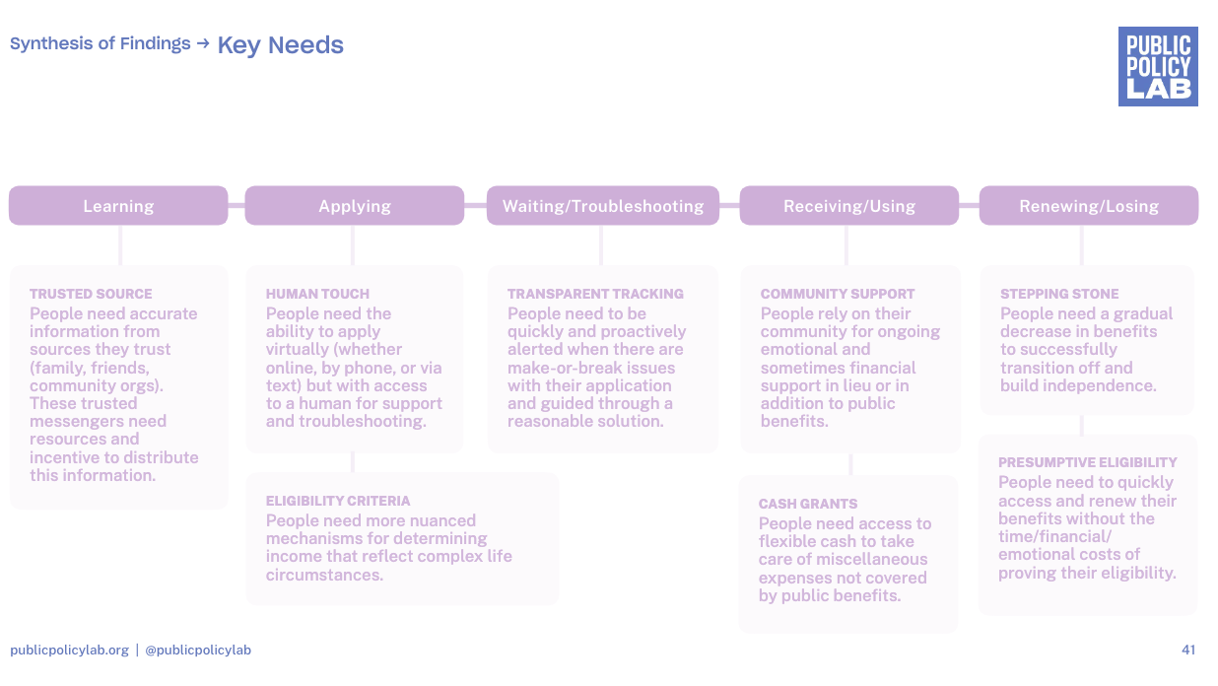
  + [Qualitative research synthesis](https://drive.google.com/file/d/1Z74lGIFgDXF5J-mEpld70477KyQVlrDM/view?usp=sharing)
  + [Additional journey map](https://drive.google.com/file/d/16qq_R_6D7DK3sHScZ_CF8QTJ0UzayZOJ/view?usp=sharing)

## What’s next

As we mentioned in our summary up top, **we know we’ll be pursuing the following goals in the near term:**

* Co-designing with benefits agencies and other collaborators to create a notifications playbook
* Prototyping & piloting a notifications-related offering
* Seeking answers to our remaining open questions

### 

In the *even nearer* term, **we are putting together** [**a recommendation to TTS leadership**](https://docs.google.com/document/d/1HIFsfYIgP8FUcue7PSZRIkdFMks0kM_9FXZdPjSoOt0/edit#) about where we think the Studio should focus next, which will reflect our next steps in more detail.